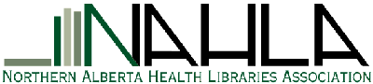

Empowering health information specialists in Northern Alberta to support health care services and research,
through leadership, advocacy, networking and education

Membership year 2017 Oct 1 to 2018 Sept 30

Last Name: ________________________ First Name: __________________________
New membership Renewal (Please check one)
Job Title: __________________________________________________________
Organization: ___________________________________________________________

Contact Information:
Address _________________________________________________________________
City/Province: ___________________ Postal Code: __________________
Telephone: ______________________
E-Mail (most frequently used address): _________________________________________
May we sign you up to the NAHLA-L listserv using the above email? Yes No
Are you a member of CHLA (Canadian Health Libraries Association)? Yes No
Are you interested in serving on a future NAHLA executive? Yes No

If you have suggestions for future NAHLA sessions, please list them here:
__________________________________________________________________________

Membership Fees: Regular $30.00 Student $15.00 Retired $15.00
The initial membership application for Retired status must include the name of a current NAHLA member who can verify that the applicant has retired.
Name of current NAHLA member: __________________________________
Paid by: Cash Cheque

Please make cheques payable to: Northern Alberta Health Libraries Association

Please return form to:
NAHLA Membership
c/o Laura Hamonic, Academic Library Resident
University of Alberta Libraries, 1-64 Cameron Library
Edmonton, Alberta, Canada T6G 2J8

Thank you! Do you require a receipt? Yes No

