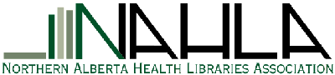

Empowering health information specialists in Northern Alberta to support health care services and research,
through leadership, advocacy, networking and education

Membership year 2016 Oct 1 to 2017 Sept 30

Last Name: ________________________ First Name: __________________________
New membership Renewal (Please check one)
Job Title: __________________________________________________________
Organization: ___________________________________________________________

Contact Information:
Address _________________________________________________________________
City/Province: ___________________ Postal Code: __________________
Telephone: ______________________
E-Mail (most frequently used address): _________________________________________
May we sign you up to the NAHLA-L listserv using the above email? Yes No
Are you a member of CHLA (Canadian Health Libraries Association)? Yes No
Are you interested in helping with a NAHLA event or serving on a future executive? ______
Would you like to have a member feature on the NAHLA website? Yes No
If you have suggestions for future NAHLA sessions, please list: _______________________
__________________________________________________________________________

Membership Fees: Regular $30.00 Student $15.00
Paid by: Cash Cheque

Please make cheques payable to: Northern Alberta Health Libraries Association

Please return form to:
NAHLA Membership
c/o Jorden Habib, Librarian
Rm. 0613, Knowledge Resource Service
Glenrose Rehabilitation Hospital
10230-111 Avenue
Edmonton, Alberta Canada T5G 0B7

Thank you! Do you require a receipt? Yes No

