NAHLA Leading Edge 3 November 2017
Searching Tips, Tricks and Hacks with Expert Searchers

Linda Slater

Easily translate search syntax from one database platform to another (e.g. Ovid Medline exp Neoplasms/ to EBSCOhost CINAHL MH "Neoplasms+"

- Copy and paste a search strategy into word and then create a macro to replace the search syntax from one database platform to another.
- It is not possible to save macros and share them with other people unless you are a computer programmer type person.
- Here are instructions on creating macros in MS Word or Excel

EBSCOhost CINAHL Tips and Tricks

- You can change the order of the search queries from bottom to top
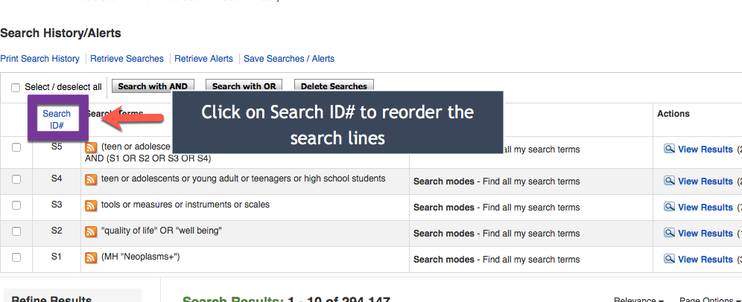

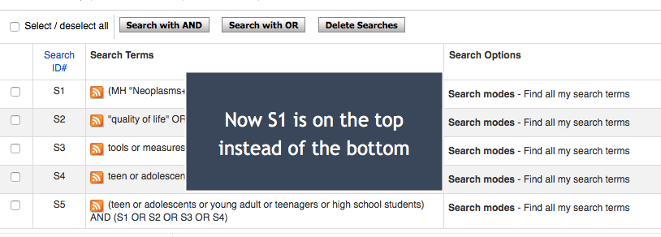

- To move references into a reference manager without the bother of putting them into the folder to export, you can have the references emailed to you as an RIS file.

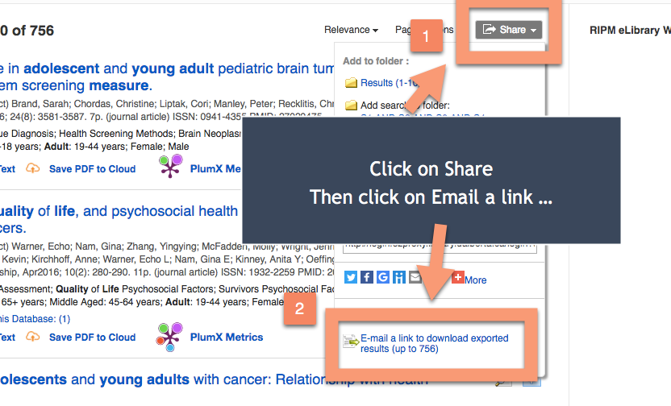

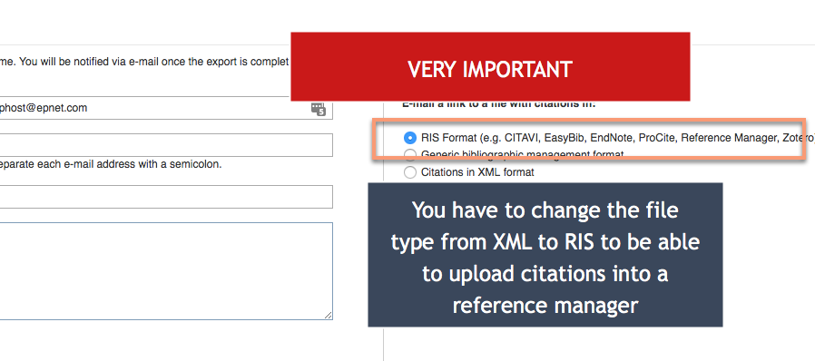

Lisa Tjosvold

Ovid Medline Tips and Tricks

  - You can run limits on multiple lines of a search strategy by clicking on each line, then choosing the limit.

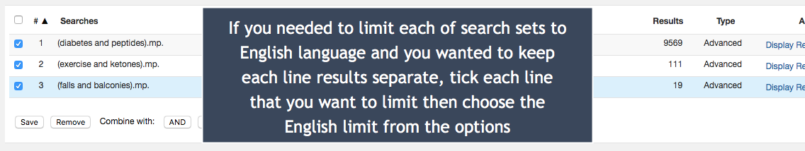

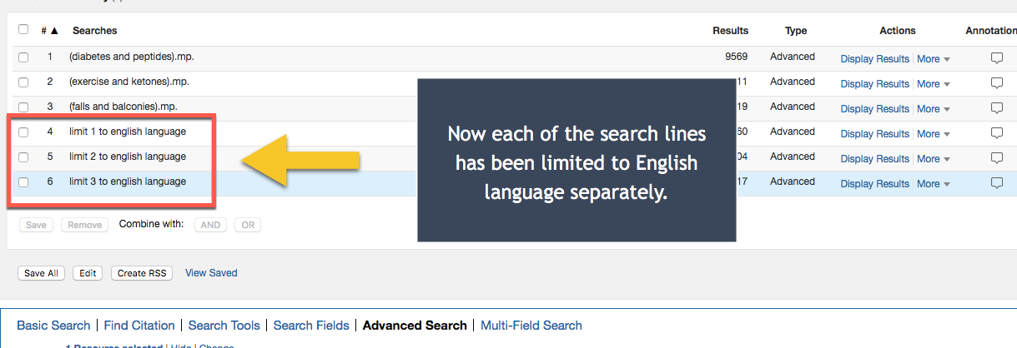

  - There are a large number of commands that you can use in the Ovid databases e.g. ..dedup to dedup lines of a search OR ..pg 1-7 to delete specific line number of a search strategy. A full list of these commands is available here.
  - You can add notes to any line of a search query by putting them in square brackets. Examples:
    - exp Neoplasms/ [this term may be too broad, it might make sense to limit to more specific types of cancer]
    - 1 or 2 or 3 or 4 [this set of results encompasses the search concept quality of life]
  - Frequency operator tells database that a term must appear at least x number of times in a particular field. Example
    - hope.ab./freq=3 In this query, the term hope must appear in the abstract field a minimum of 3 times.

Sharna Polard

Palliative Care Searching Resource

- An excellent resource for palliative care search filters is CARESEARCH.
- It includes a number of search filters on a wide variety of topics and a large amount of grey literature (be aware that the site is Australian so much of the grey lit is from Australia).

